

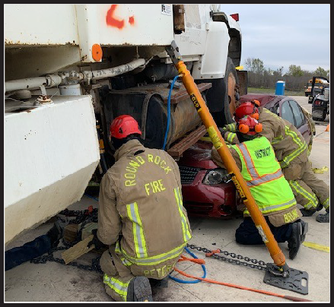

# October 8-10, 2025



* Multiple hands on scenarios
* Realistic scenario challenges
* Commercial buses & school buses
* Tractor / trailers, bobtails & cement trucks
* Latest big rig extrication techniques



* Overturns, **over-rides, an**d under-rides
* Working with heavy tow trucks
* Industry leading instructors
* Commercial vehicle anatomy
* Advanced heavy stabilization
* Heavy lifting techniques
* Latest extrication & stabilization equipment



* Texas Big Rig Rescue Technician Certificate
* Texas Big Rig Rescue Academy T-shirt
* Lunch & refreshments all 3 days



# $675.00

**65**

